Short Wave Infrared Neuromodulation Gadget

Cameron R. Author, *Member, IEEE* , Matthew T. Author, Bibhus L. Author, Krishna S. Sponsor, *Member, IEEE* , John L. Mentor, *Member, IEEE*

***Abstract* — Direct stimulation of neurons in the brain can potentially treat many diseases, such as Parkinson’s or Alzheimer’s disease. Direct stimulation, whether it be through electric or photonic stimulation, provided a way to activate neurons in the brain and treat diseases and conditions. However, this kind of invasive stimulation can have risks that lead to worsening the condition or cause infection. The Short-Wave Infrared Neuromodulation Gad- get (SWING) aimed to build and test a non-invasive optical method of stimulation with funding provided by the KIND Laboratory’s Brain IMPACT project. SWING is part of the two semester long Electrical and Computer Engineering capstone sequence at The Ohio State University.**



**SWING used a cubic extrapolation to approximate the optical coefficients of biological tissue at 1550 nm. Monte Carlo eXtreme (MCX) was then used to predict the expected photon distribution and intensity throughout a model of the human head. MCX was ran multiple times with dif- ferent positions and wavelengths using The Ohio State Supercomputer. MCX showed that deep brain stimulation is possible at all the wavelengths tested. Based on the MCX results, 1550nm wavelength is the best choice for further testing. Solving the problems previously discussed has the potential to reduce the effects of brain disorders on the general population, mitigate the risks of surgery that patients would have to go through if done invasively, and to improve overall health.**

***Index Terms*—**

1. Introduction

**T**

HERE are many physical issues in the brain, including Parkinson’s disease and functional problems such as attention-deficit/hyperactivity disorder (ADHD) and depres- sive disorders. A solution to such problems that has been explored recently in the Neurotech community is one that involves a direct stimulation of neuronal connections in the brain [1], [2]. Direct neuronal stimulation, whether it be through electric or photonic stimulation, provides a way to control mechanisms in the brain and treat diseases and con- ditions. These treatments result in an improvement of the effects caused by these diseases and conditions. However, most modern neuromodulation strategies are invasive in nature, and there are limited options for a non-invasive approach to neuromodulation for medical benefit. Many invasive tech- niques involve surgical implants and increase the risk of brain hemorrhage and worsening mental and emotional status for some patients, that often make the cons worse for life- threatening conditions [1], [3]. As a result, SWING looks to

investigate a non-invasive method for neuromodulation using a near-infrared photonic stimulation method.

1. Methods

TIRE’s software and simulation consist of two main com- ponents: software for data preprocessing and simulation for modeling and photon distribution. The preprocessing stage involves approximating optical coefficients at 1550 nm to build the Optical Phantom. Monte Carlo eXtreme (MCX) is used for simulating the behavior of the laser as it scatters and is absorbed through the Optical Phantom head, providing a model of photon dispersion in biological tissue using known or approximated optical coefficients.

1. *Software Preprocessing*

In the software preprocessing stage, TIRE aims to ap- proximate the optical coefficients of the unknown layers in the Optical Phantom. Optical coefficient data for the scalp, skull, gray matter (GM), and white matter (WM) are obtained from [SOURCE]. The wavelength ranges for each layer are as follows: scalp (805-2000 nm), skull (801-2000 nm), gray matter (400-1300 nm), and white matter (400-1300 nm). The data for scalp and skull cover the wavelength of interest (1550 nm), but the data for gray and white matter do not. To address this, Python is used to process the data and extrapolate the unknown layers to 1550 nm.

First, known data points are plotted, and a cubic interpola- tion is applied between each point to obtain continuous lines for the four biological tissue layers. This cubic interpolation provides a complex fit while preventing over-fitting in the initial steps. To extrapolate the gray and white matter to 1550 nm, the overlapping region of the four tissues (801-1300 nm) is examined.

Vertical offset values between the unknown layers (gray matter and white matter) and the known layers (scalp and skull) are calculated throughout the overlapping region. These offset values are averaged, resulting in two average vertical off- sets for each unknown layer. The extrapolation model extends the unknown layers by adding the previously calculated offsets to the known scalp and skull data. This process is repeated to calculate a third extrapolation by taking the average of the scalp and skull extrapolations. The results are visualized in Figures 7, 8, and 9, showing the extrapolated lines and marker denoting the extrapolated values at 1550 nm.

1. *Simulation using MCX*

MCX, a Monte Carlo simulation tool, is employed for visualizing the beam intensity within the head. It models the photon dispersion in biological tissue using optical coefficients obtained from experimental data or approximations, as in the case of SWING. MCX creates a mesh model of the human brain using an accumulation of MRI images, incorporating layers such as scalp, skull, cerebrospinal fluid (CSF), gray mat- ter, white matter, and air bubbles. Thickness variations in the layers are specified using thinning or thickening operators. To

IV. Discussion

V. Conclusion Acknowledgment

References

1. “Novel Neuromodulation Techniques,“ in *IEEE Pulse*, Aug. 2016. [https://www](http://www.embs.org/pulse/articles/novel-neuromodulation-techniques/).embs.or[g/pulse/articles/novel-neuromodulation-techniques/](http://www.embs.org/pulse/articles/novel-neuromodulation-techniques/)
2. “Deep Brain stimulation,“ in *Mayo Clinic*, Sep. 2021. [https://www.mayoclinic.org/tests-procedures/deep-brain-stimulation/about/pac-2038456](http://www.mayoclinic.org/tests-procedures/deep-brain-stimulation/about/pac-2038456)
3. C. C. medical professional, “Deep Brain Stimulation (DBS): What it is, Purpose & procedure,“ in *Cleveland Clinic*,

https://my.clevelandclinic.org/health/treatments/21088-deep-brain-stimulation#risks–ben

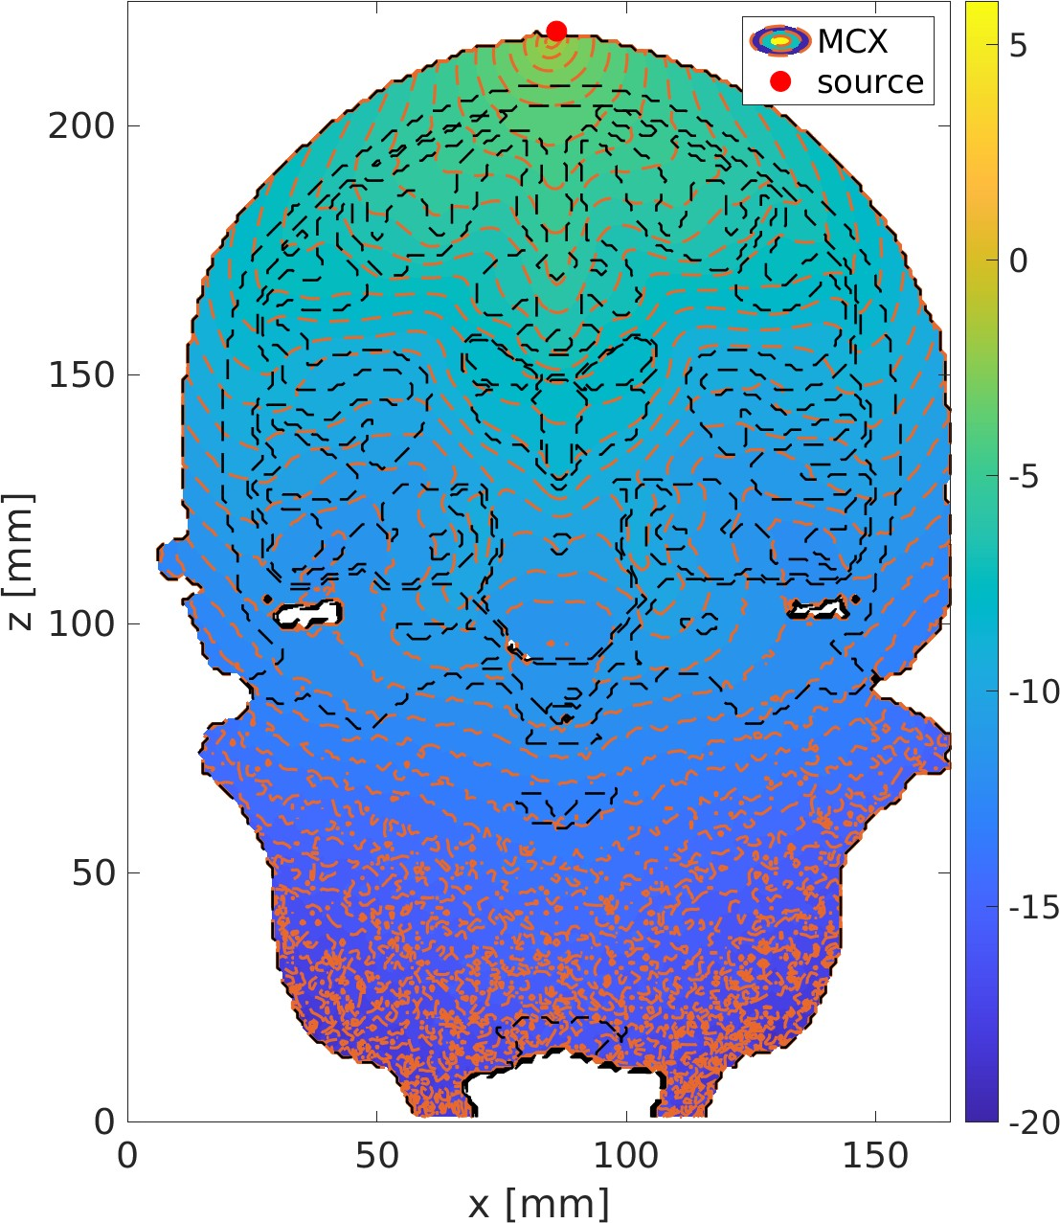create the simulation, the optical coefficients, particularly the absorption and scattering coefficients, are input into the MCX software. This allows for the simulation of photon absorption and scattering as they pass through the brain tissue, enabling visualization of beam intensity at different points in the brain. Additionally, TIRE utilizes the software to investigate various aspects of photon dispersion. This includes studying the impact of different tissue layers on beam intensity and exploring the effects of laser parameters such as wavelength, illumination area size, and the number of incident photons on the phantom. The differences between absorption coefficients at 1550 nm compared to other wavelength be observed and noted in the figures, and this model can be utilized for experimental data validation.

1. RESULTS

Table I displays the estimated absorption and scattering coefficients for each of the biological tissue layers as well as each wavelength. These values were calculated using the interpolation-extrapolation method detailed in Section II. To determine the reliability of this prediction method, SWING used the Python library ”scikit-learn” to calculate the R- squared value when predicting known data. This R-squared value was calculated as 0.4980, indicating that 49.80% of the variability in the unknown coefficients is explained by SWING’s predicition model.

TABLE I

Estimated Optical Coefficients

|  |  |  |  |
| --- | --- | --- | --- |
| Tissue Type | Wavelength, nm | Absorption Coefficient  *µa*, cm*−*1 | Scattering Coefficient  *′*  *µs*, cm*−*1 |
| Scalp | 810 | 0.505 | 14.145 |
|  | 980 | 0.365 | 16.714 |
|  | 1064 | 0.168 | 17.029 |
|  | 1550 | 1.649 | 14.578 |
| Skull | 810 | 0.099 | 19.248 |
|  | 980 | 0.230 | 17.380 |
|  | 1064 | 0.101 | 16.180 |
|  | 1550 | 2.715 | 15.543 |
| Gray Matter | 810 | [0.455,0.605,0.744] | [3.896,6.030,8.211] |
|  | 980 | [0.586,0.601,0.610] | [6.343,6.380,6.444] |
|  | 1064 | [0.413,0.438,0.457] | [5.143,5.938,6.740] |
|  | 1550 | [1.870,2.485,3.071] | [4.246,4.393,4.506] |
| White Matter | 810 | [0.737,0.888,1.027] | [24.237,26.403,28.617] |
|  | 980 | [0.868,0.883,0.893] | [26.749,26.753,26.785] |
|  | 1064 | [0.696,0.720,0.739] | [25.549,26.311,27.081] |
|  | 1550 | [2.153,2.767,3.353] | [24.587,24.767,24.911] |

Fig. 1. 810 nm CZ Position

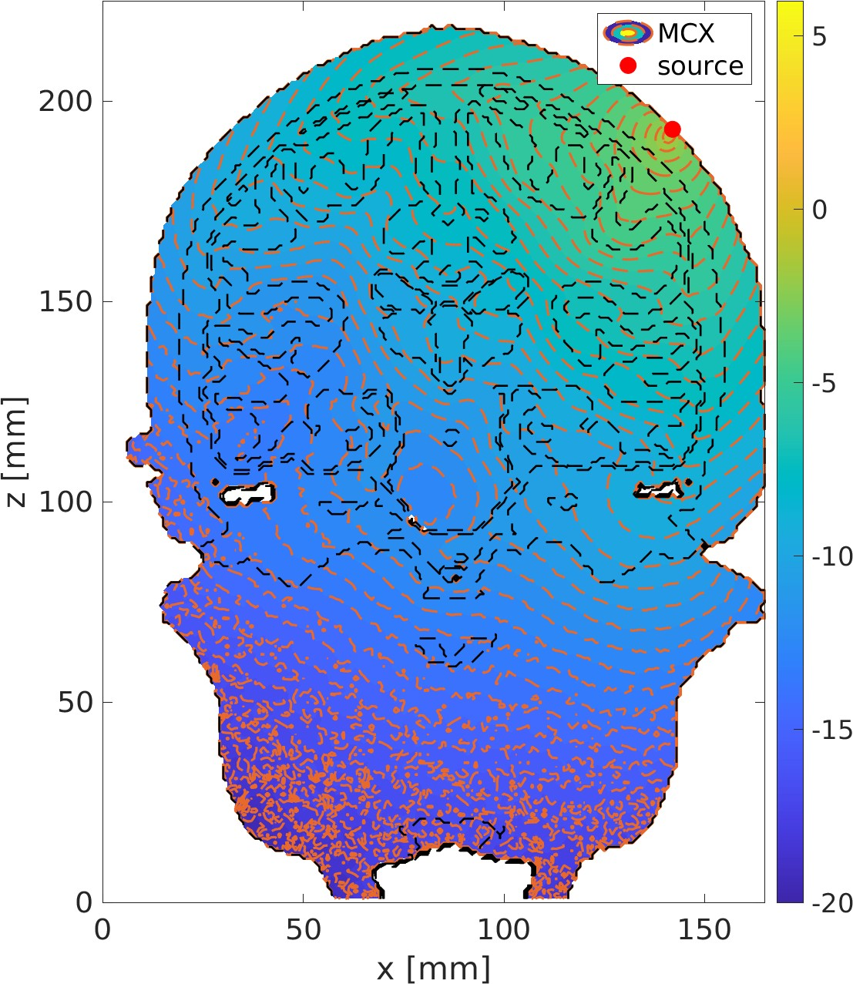

Fig. 2. 810 nm 45 Degree Position

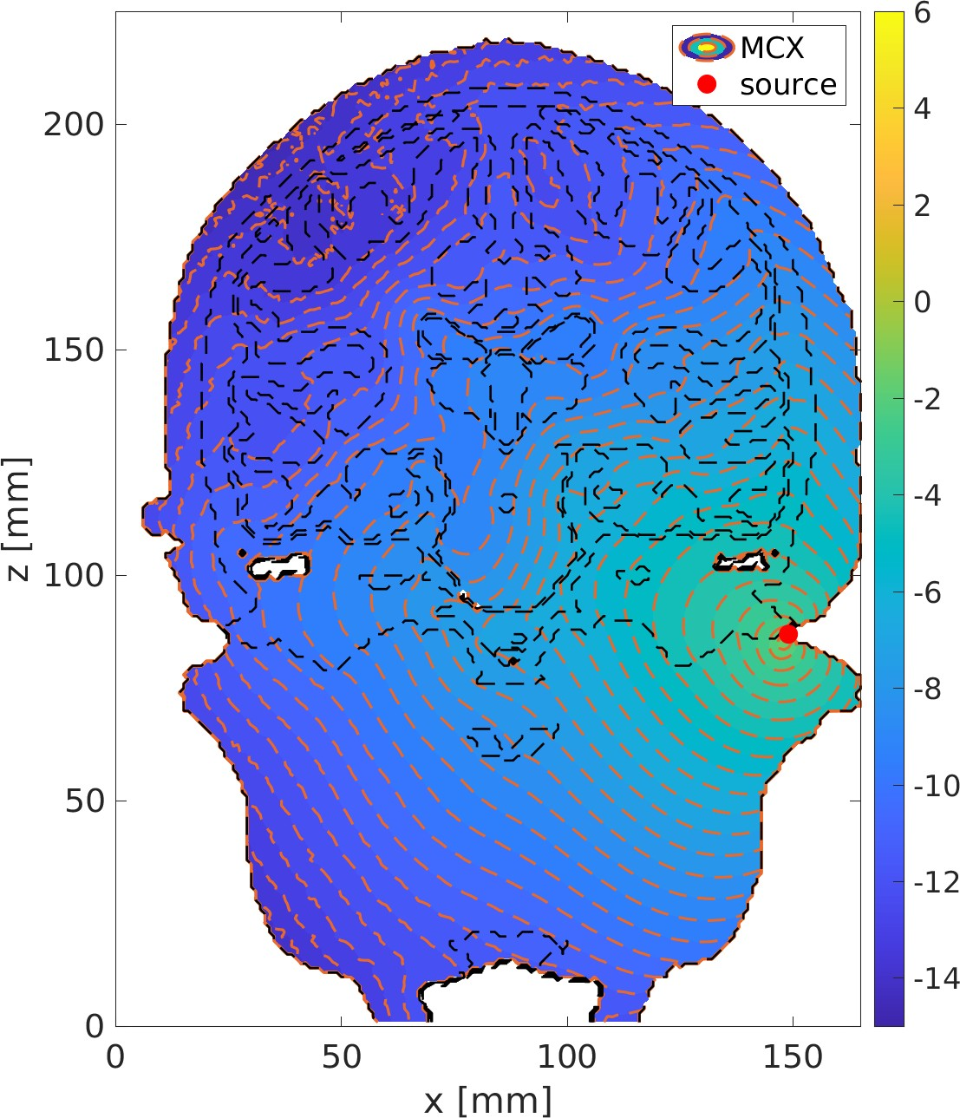 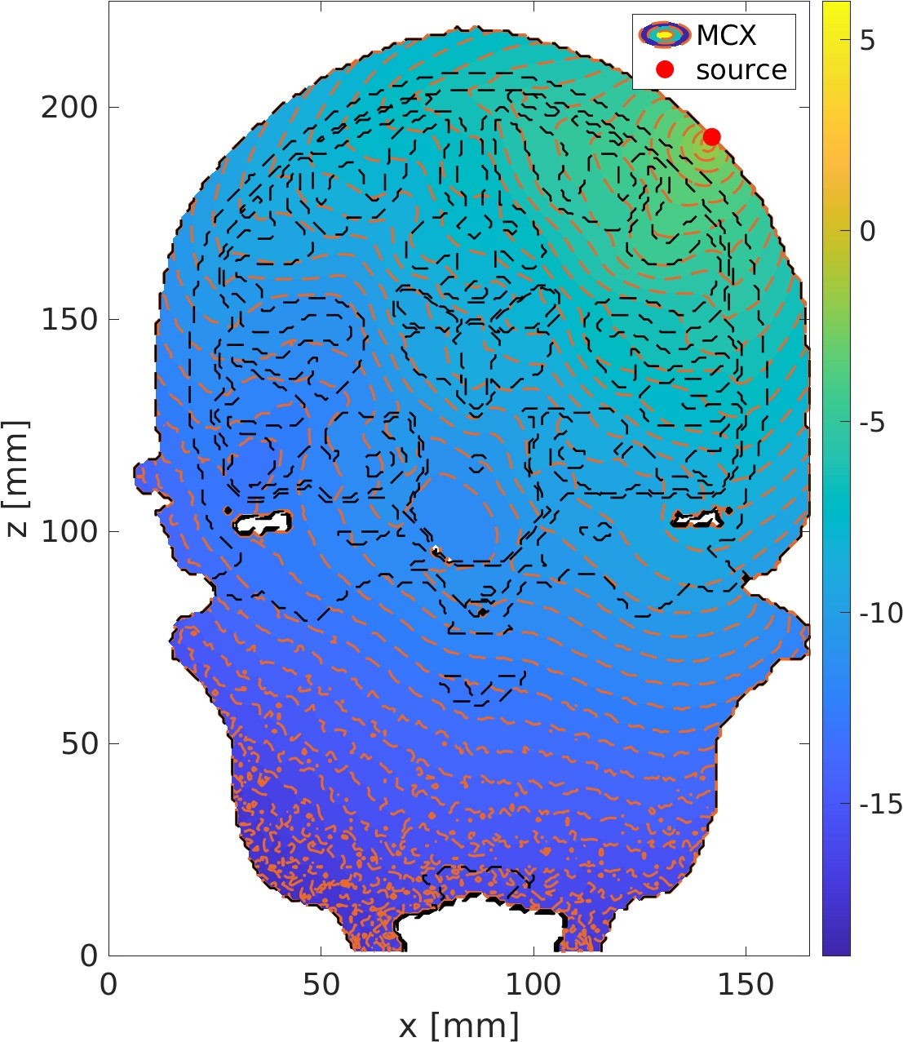

Fig. 3. 810 nm Cochlear Position Fig. 6. 980 nm 45 Degree Position

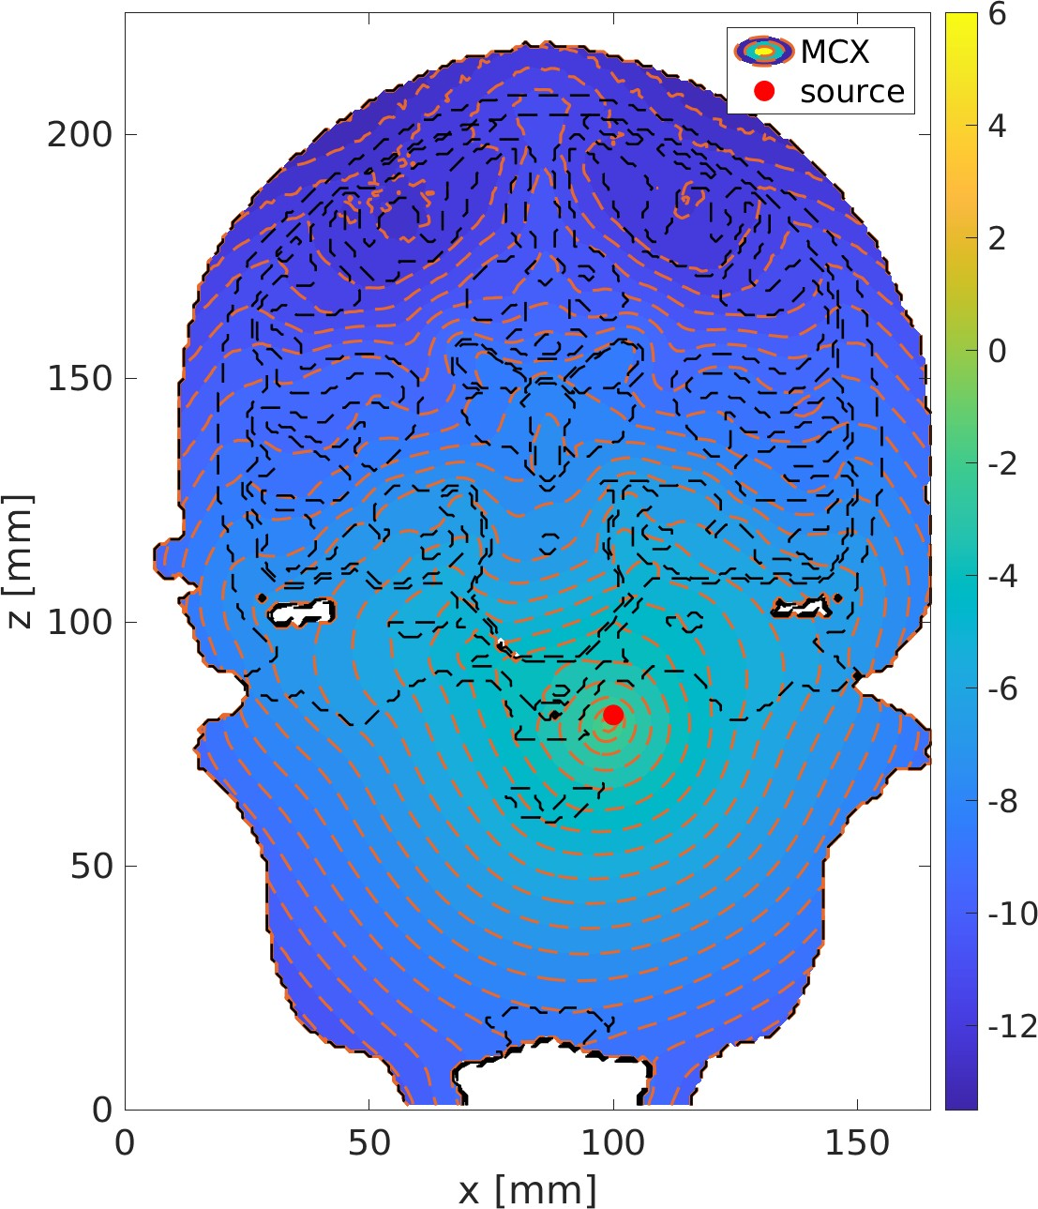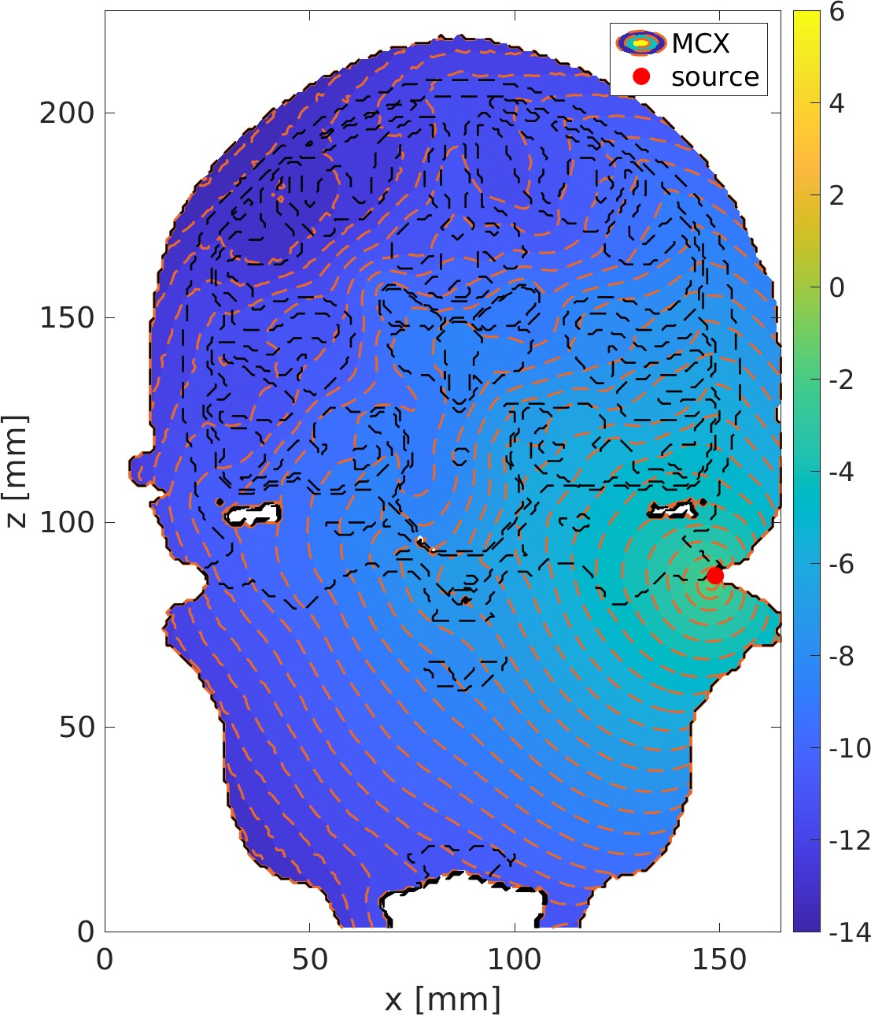

Fig. 4. 810 nm Intranasal Position Fig. 7. 980 nm Cochlear Position

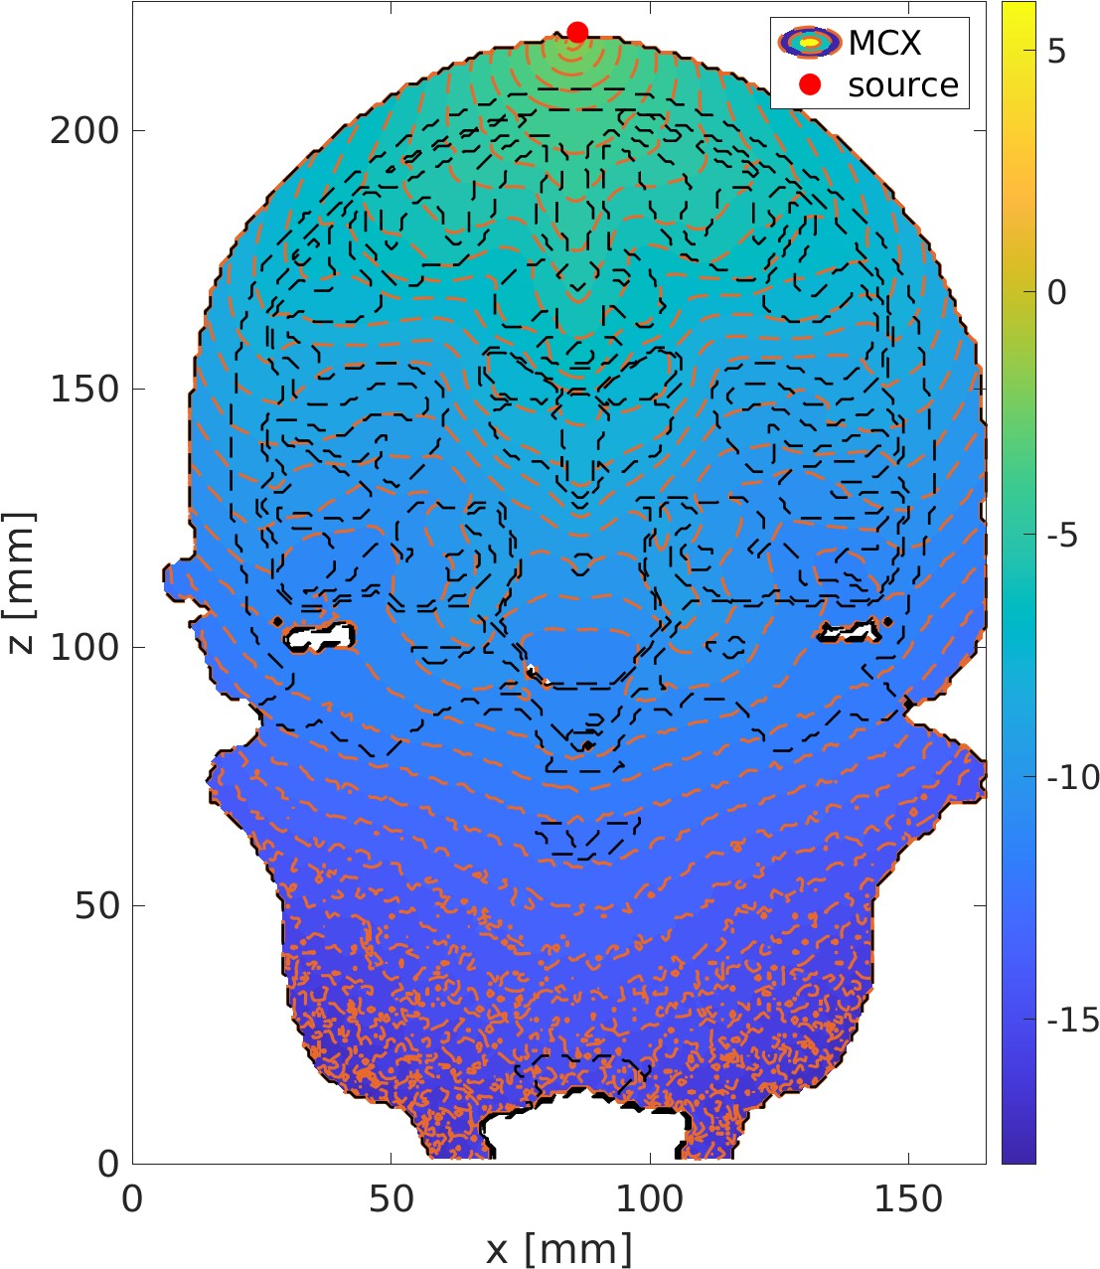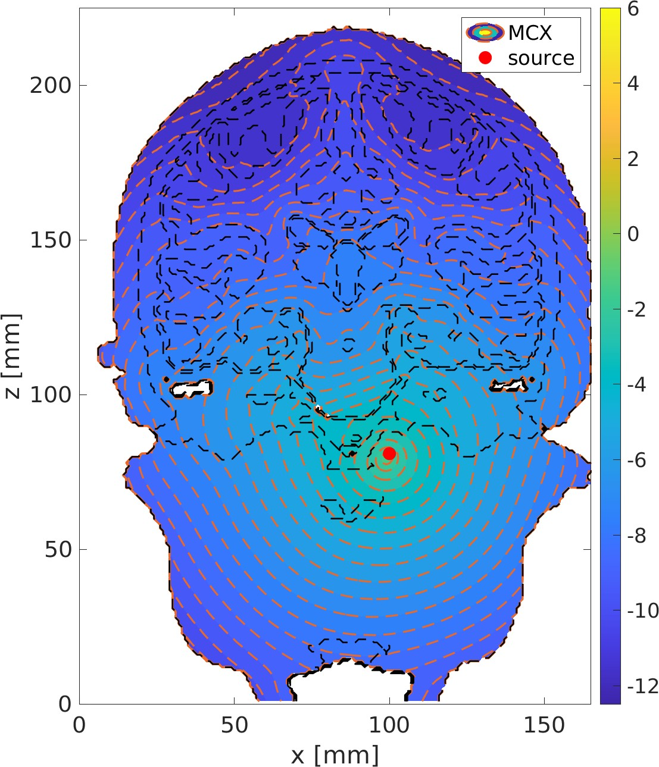

Fig. 5. 980 nm CZ Position Fig. 8. 980 nm Intranasal Position

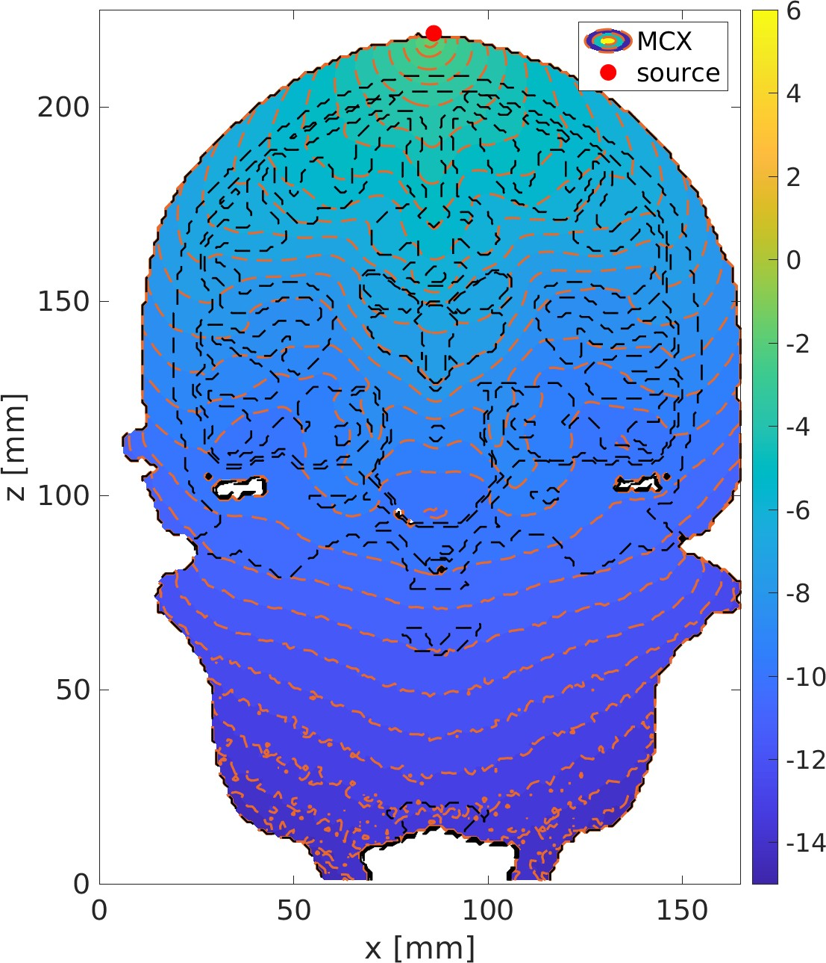 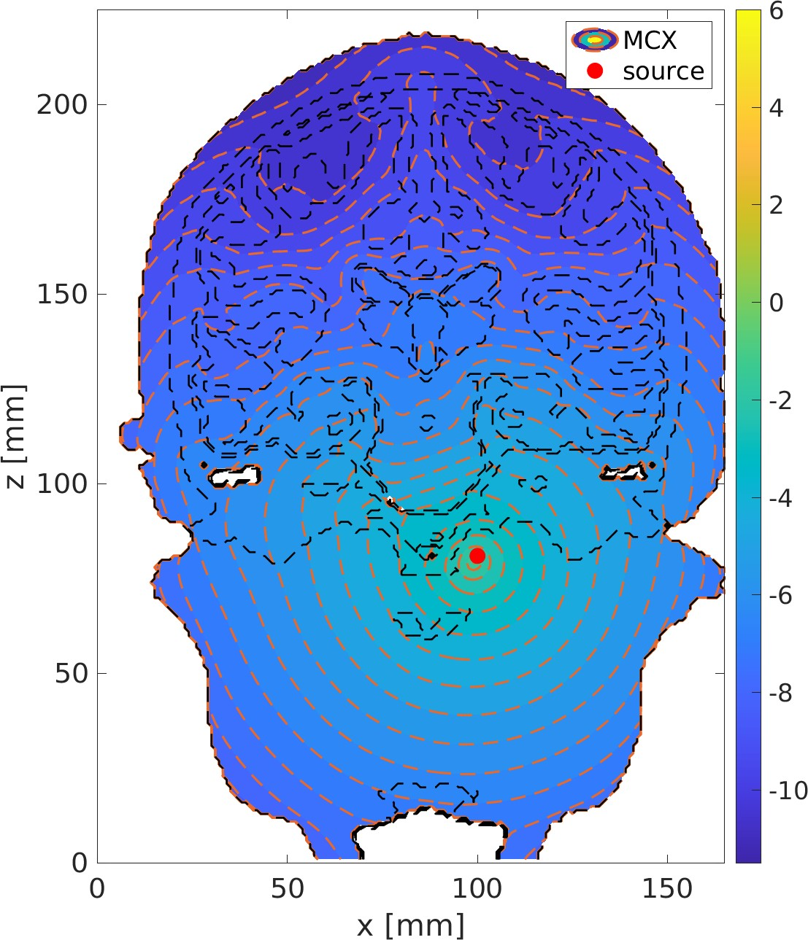

Fig. 9. 1064 nm CZ Position Fig. 12. 1064 nm Intranasal Position

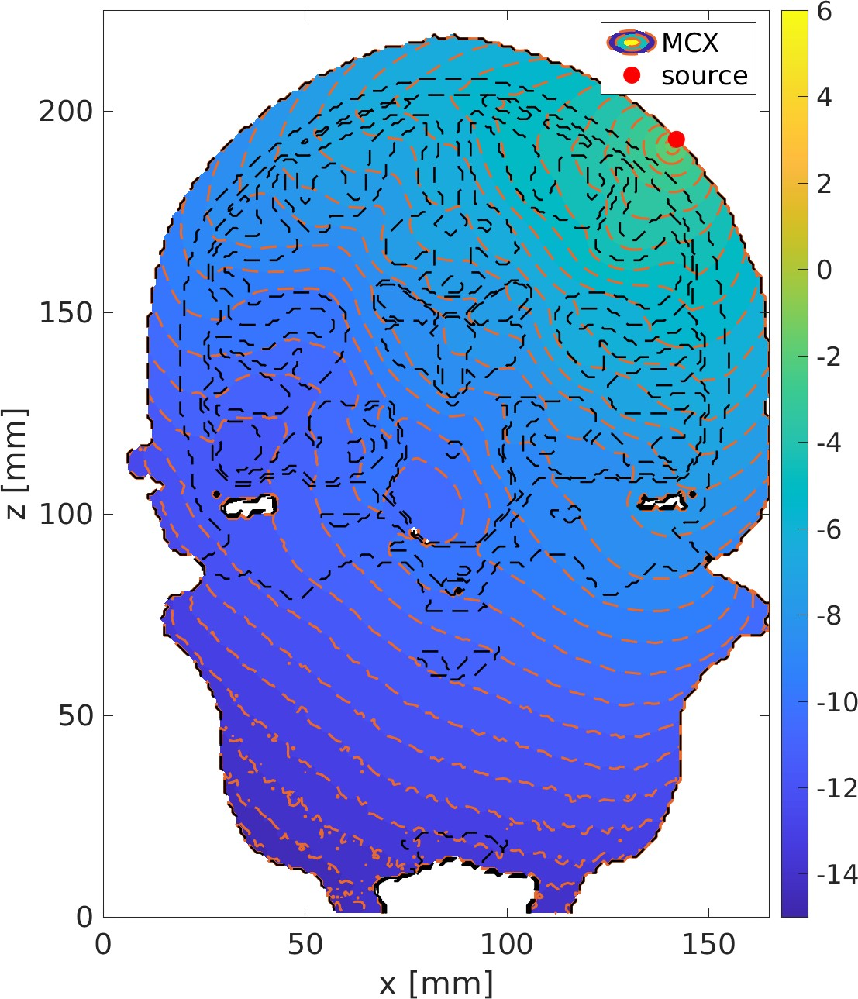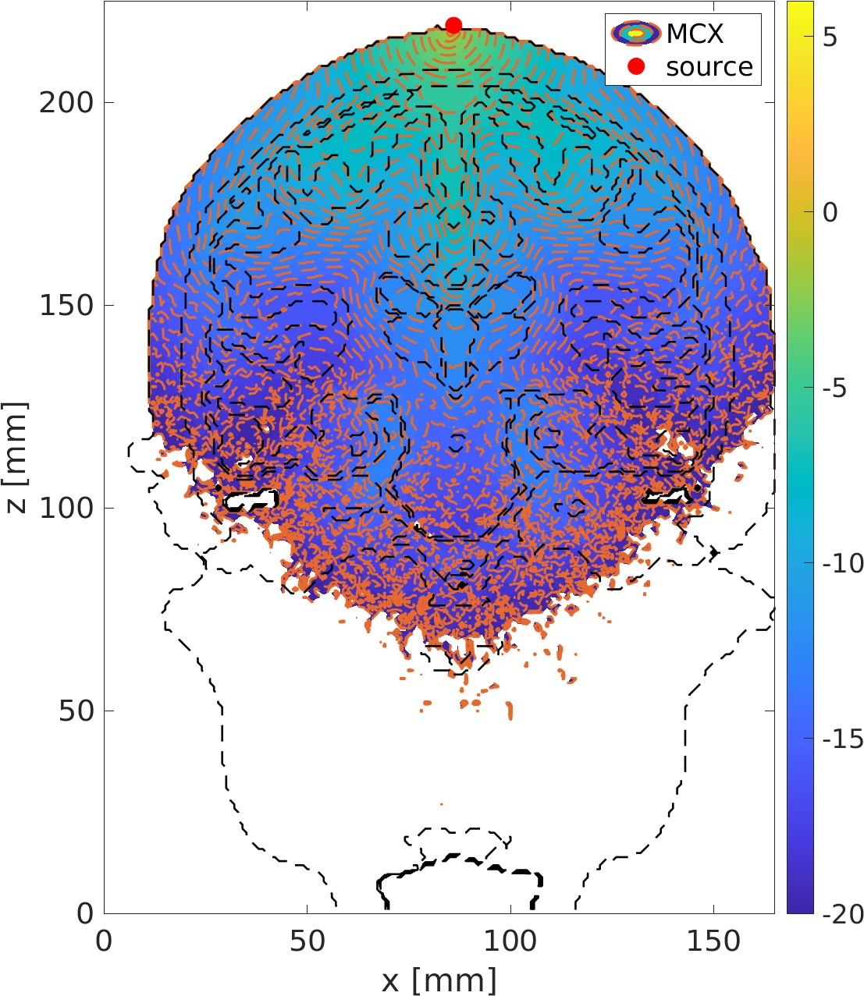

Fig. 10. 1064 nm 45 Degree Position Fig. 13. 1550 nm CZ Position

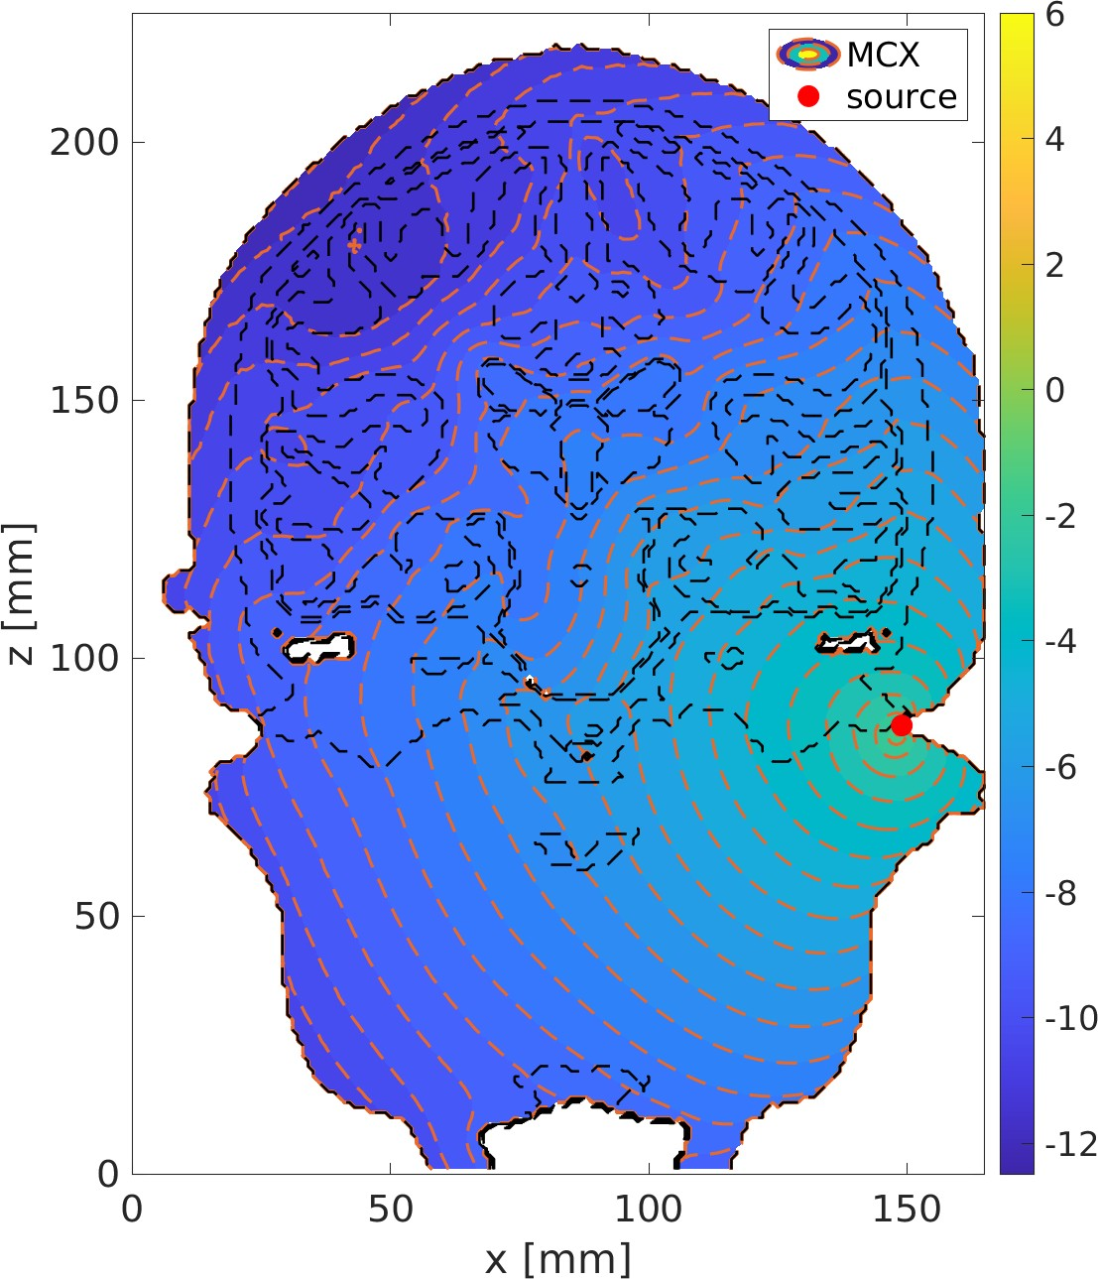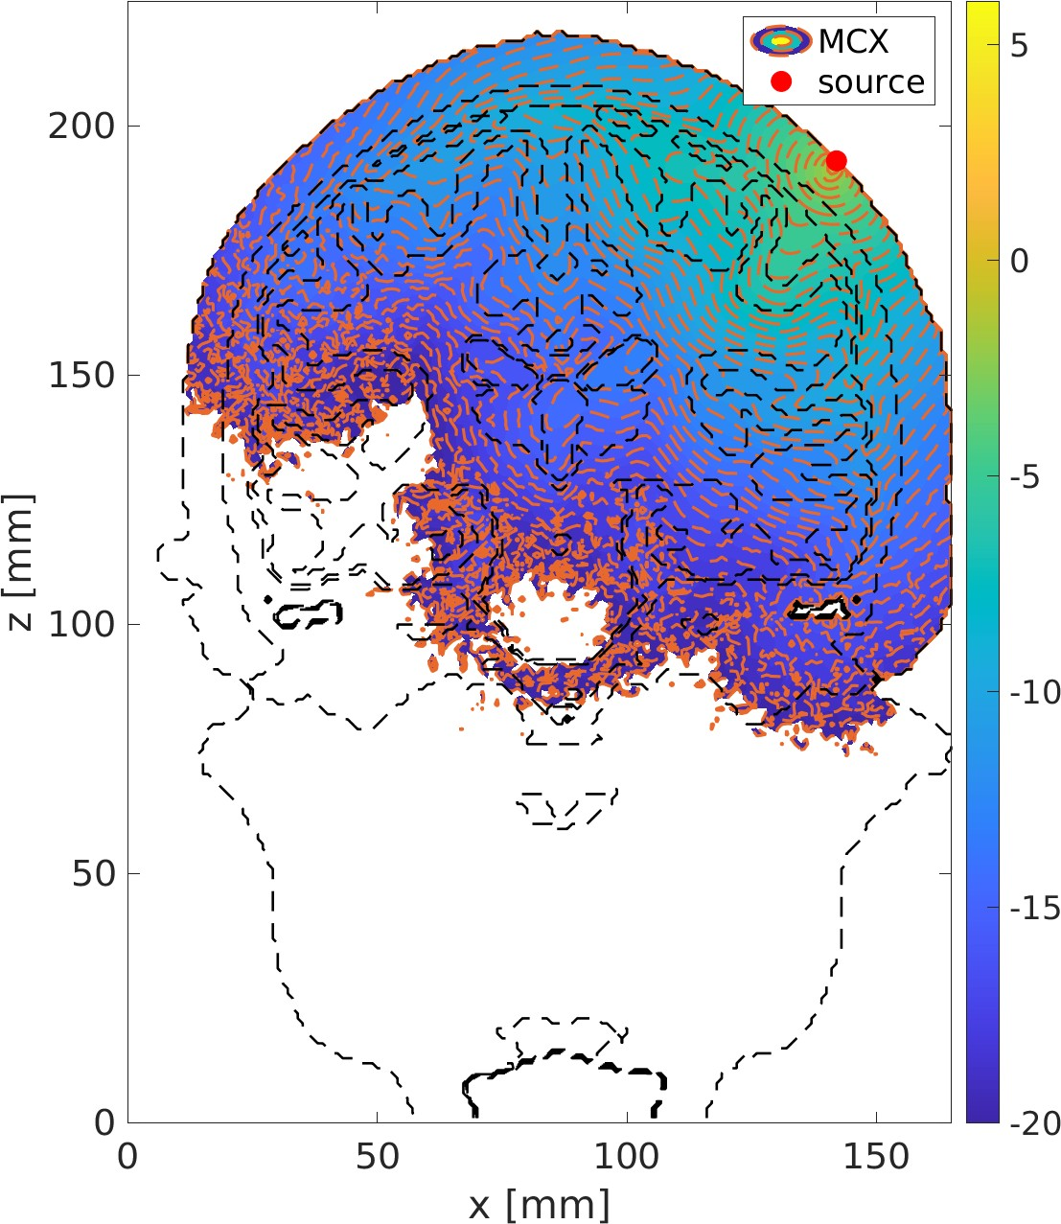

Fig. 11. 1064 nm Cochlear Position Fig. 14. 1550 nm 45 Degree Position

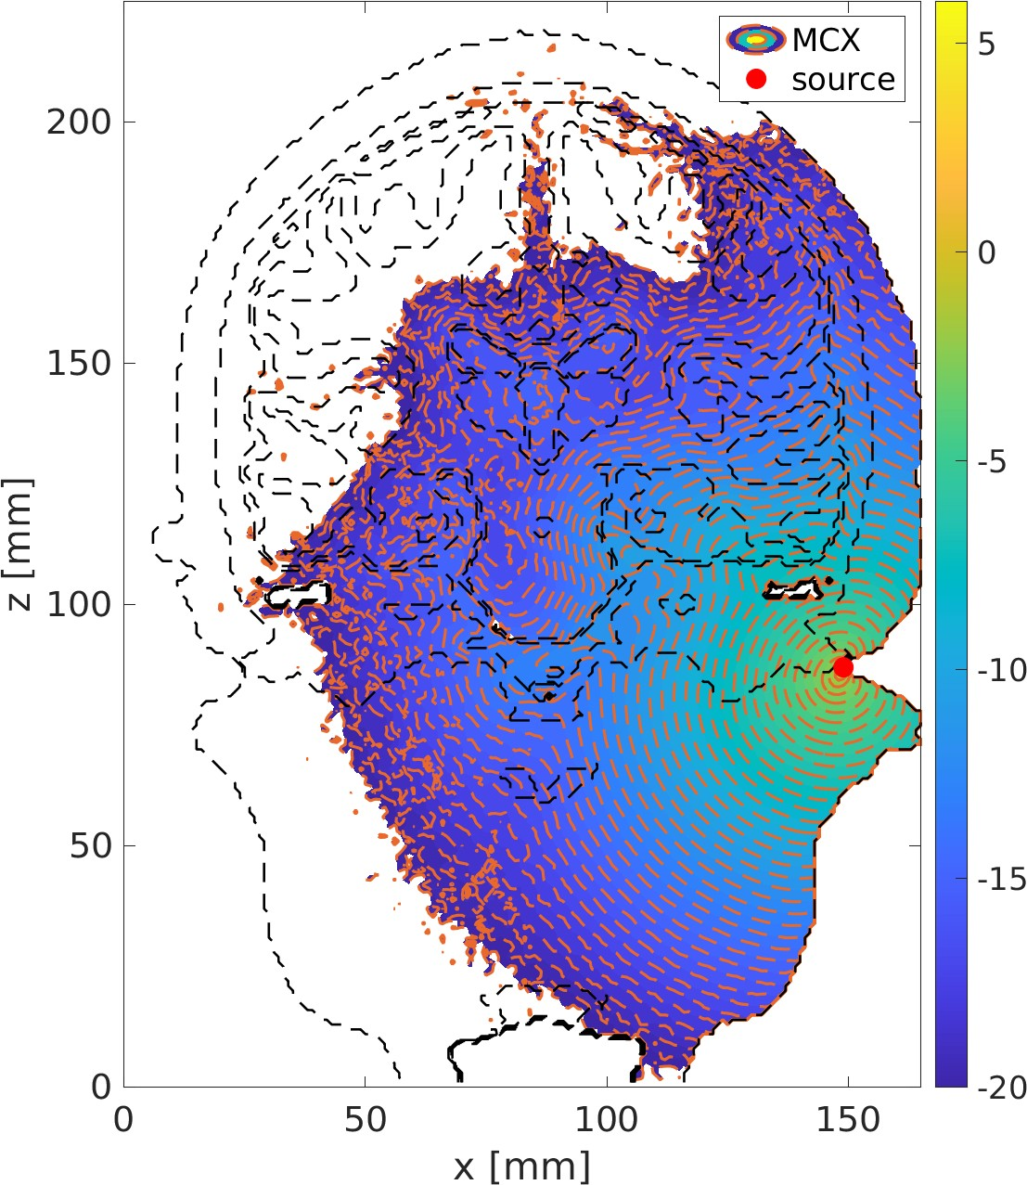

Fig. 15. 1550 nm Cochlear Position

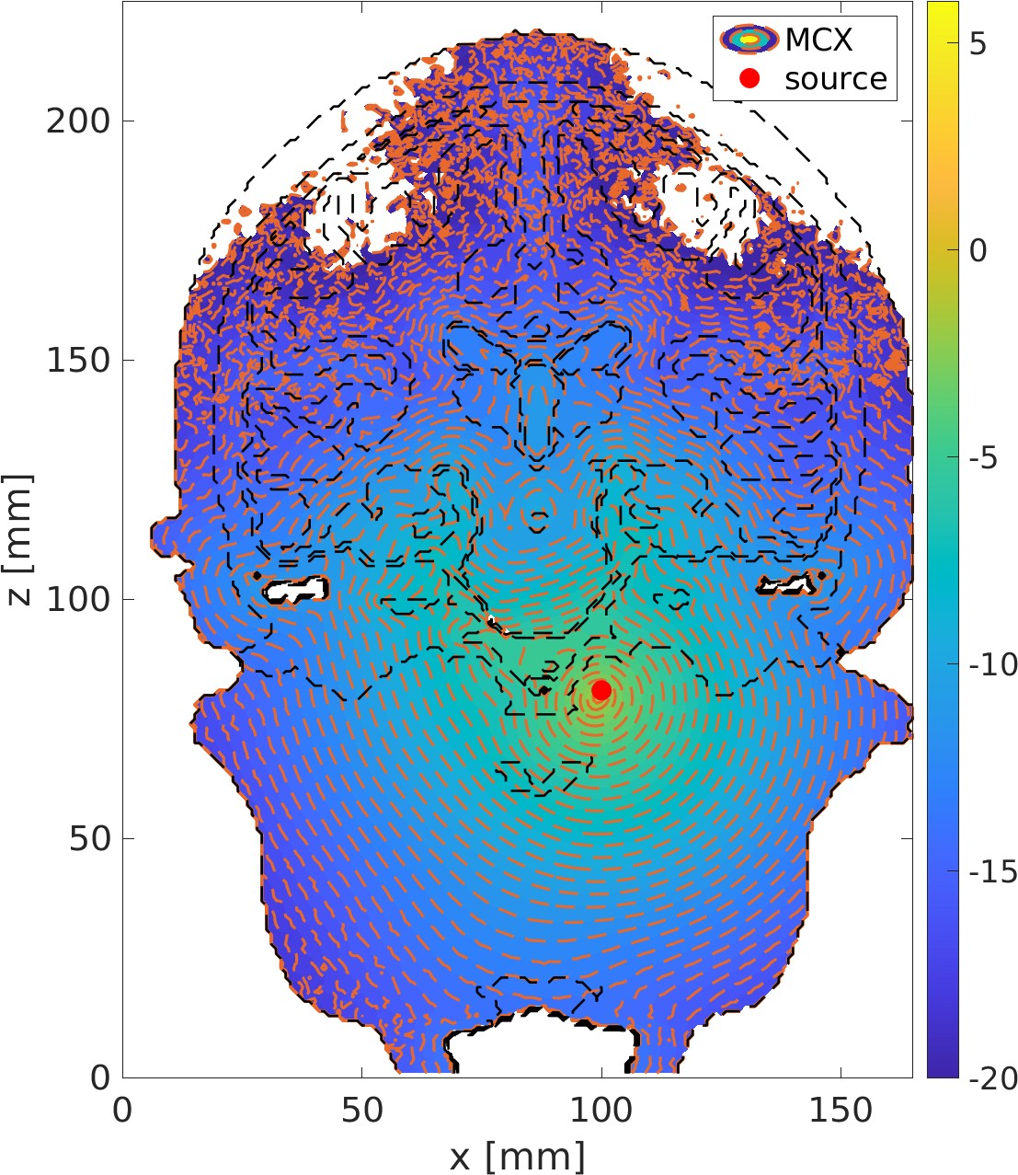

Fig. 16. 1550 nm Intranasal Position